MICROCONTROLLER & APPLICATION

NAME : SAHIL TRIPATHI

SEMESTER : VTH

ASSIGNMENT

CASE STUDY OF MICROCONTROLLER AND ITS ONE PERIPHERAL

MANUFACTURER : STMicroelectronics

PRODUCT NUMBER : STM32F100R4T6B

DATA SHEET URL : <https://www.st.com/resource/en/datasheet/stm32f100cb.pdf>

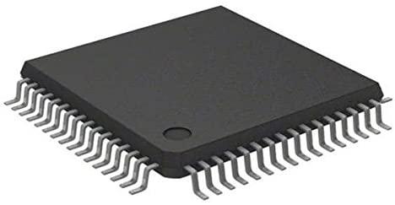

ABOUT STM32F100R4T6B-

* It incorporate the high-performance ARM® Cortex®-M3 32-bit RISC core operating at a 24MHz frequency, high-speed embedded memories (Flash memory up to 128 Kbytes and SRAM up to 8 Kbytes), and an extensive range of enhanced peripherals and I/Os connected to two APB buses.

* All devices offer standard communication interfaces (up to two I2Cs, two SPIs, one HDMI CEC, and up to three USARTs), one 12-bit ADC, two 12-bit DACs, up to six
* General-purpose 16-bit timers and an advanced-control PWM timer.

FEATURES OF STM32F100R4T6B-

# Core: ARM® 32-bit Cortex®-M3 CPU

1. 24 MHz maximum frequency,
2. 1.25 DMIPS/MHz (Dhrystone 2.1) performance

3- Single-cycle multiplication and hardware division

# MEMORIES

1. 16 to 128 Kbytes of Flash memory
2. 4 to 8 Kbytes of SRAM

CLOCK RESET AND SUPPLY MANAGEMENT

1. 2.0 to 3.6 V application supply and I/Os
2. POR, PDR and programmable voltage
3. detector (PVD)
4. 4-to-24 MHz crystal oscillator
5. Internal 8 MHz factory-trimmed RC
6. Internal 40 kHz RC
7. PLL for CPU clock
8. 32 kHz oscillator for RTC with calibration

LOW POWER

1. Sleep, Stop and Standby modes
2. VBAT supply for RTC and backup registers

DEBUG MODE

1. Serial wire debug (SWD) and JTAG interfaces

# DMA

1. 7-channel DMA controller
2. Peripherals supported: timers, ADC, SPIs,
3. I2Cs, USARTs and DACs

# 1 × 12-bit, 1.2 μs A/D converter (up to 16 channels)

1. Conversion range: 0 to 3.6 V
2. Temperature sensor

# 2 × 12-bit D/A converters

# Up to 80 fast I/O ports

1. 37/51/80 I/Os, all mappable on 16 external
2. interrupt vectors and almost all 5 V-tolerant

# UP TO 12 TIMERS

1. Up to three 16-bit timers, each with up to 4
2. IC/OC/PWM or pulse counter
3. 16-bit, 6-channel advanced-control timer:
4. up to 6 channels for PWM output, dead
5. time generation and emergency stop
6. One 16-bit timer, with 2 IC/OC, 1
7. OCN/PWM, dead-time generation and
8. emergency stop

PIN DIAGRAM OF STM32F100R4T6B-

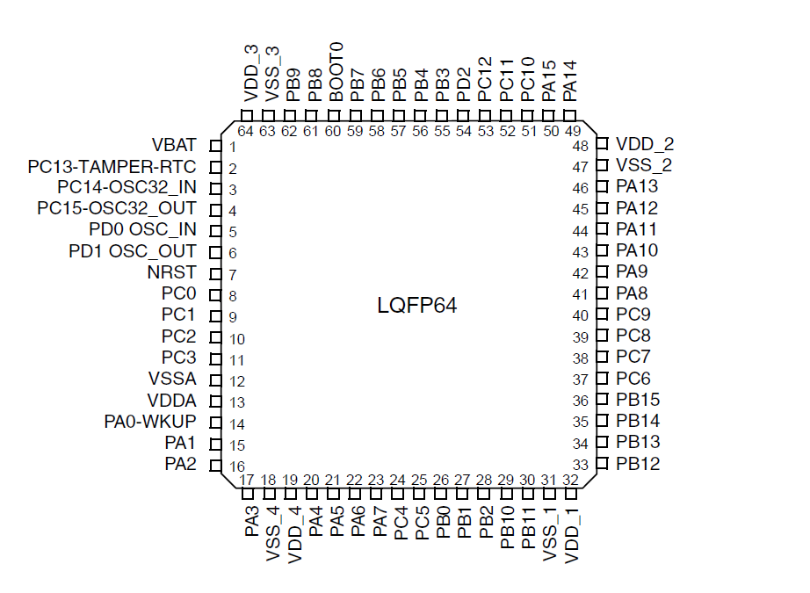

PECULARITIES OF STM32F100R4T6B-

1. SysTick timer: 24-bit down counter
2. Two 16-bit basic timers to drive the DAC
3. Up to 8 communications interfaces
4. Up to two I²C interfaces (SMBus / PMBus)
5. Up to 3 USARTs (ISO 7816 interface, LIN, IrDA capability, modem control)
6. Up to 2 SPIs (12 Mbit/s)
7. Consumer electronics control (CEC) interface
8. 2 watchdog timers (Independent and Window)
9. SysTick timer: 24-bit down counter

ATTRIBUTES OF STM32F100R4T6B-

|  |  |
| --- | --- |
| CORE PROCESSOR | ARM CORTEX –M3 |
| CORE SIZE | 32 BIT |
| SPEED | 24MHZ |
| CONNECTIVITY | I^2C IrDA LINbus , UART/USART |
| PERIPHERAL | DMA PDR POR PWM TEMP SENSOR WDT |
| PROGRAM MEMORY SIZE | 16KB(16K x8) |
| PROGRAM MEMORY TYPE | FLASH |
| RAM SIZE | 4K x 8 |
| VOLTAGE SUPPLY | 2V ~ 3.6V |
| DATA CONVERTERS | A/D 16x12b; D/A 2x12b |
| OSCILLATOR TYPE | INTERNAL |
| OPERATING TEMPERATURE | -40C TO 85C |
| MOUNTING TYPE | SURFACE MOUNT |
| NUMBER OF I/0 | 51 |

PERIPHERALS IN STM32F100R4T6B-

PERIPHERALS USED IN STM32F100R4T6B-

* DMA : DIRECT MEMORY ACCESS
* PDR : POWER DOWN RESET
* POR : POWER ON RESET
* PWM : PULSE WIDTH MODULATION
* TEMPERATURE SENSOR
* WDT : WATCHDOG TIMER

# STUDY OF PERIPHERAL

# WATCH DOG TIMER

The STM32F100xx devices include an advanced-control timer, six general-purpose timers, two basic timers and two watchdog timers.

|  |  |  |  |  |  |  |
| --- | --- | --- | --- | --- | --- | --- |
| TIMER | COUNTER RESOLUTION | COUNTER TYPE | PRESCALAR | DMA REQUEST | CAPTURE CHANNEL | COMPLEMENTARY  OUTPUT |
| TIM1 | 16 BIT | UP/DOWN | 1-65536 | YES | 4 | YES |
| TIM2,TIM3,TIM4 | 16 BIT | UP/DOWN | 1-65536 | YES | 4 | NO |
| TIM 15 | 16 BIT | UP | 1-65536 | YES | 2 | YES |
| TIM16,TIM17 | 16 BIT | UP | 1-65536 | YES | 1 | YES |
| TIM 16,TIM 17 | 16 BIT | UP | 1-65536 | YES | 0 | NO |

# ADVANCED CONTROL TIMER (TIM 1)

The advanced-control timer (TIM1) can be seen as a three-phase PWM multiplexed on 6

channels. It has complementary PWM outputs with programmable inserted dead times. It

can also be seen as a complete general-purpose timer. The 4 independent channels can be

used for:

• Input capture

• Output compare

• PWM generation (edge or center-aligned modes)

• One-pulse mode output

If configured as a standard 16-bit timer, it has the same features as the TIMx timer. If

configured as the 16-bit PWM generator, it has full modulation capability (0-100%).

# TIM2, TIM3, TIM4

STM32F100xx devices feature three synchronizable 4-channels general-purpose timers.

These timers are based on a 16-bit auto-reload up/downcounter and a 16-bit prescaler.

They feature 4 independent channels each for input capture/output compare, PWM or onepulse

mode output. This gives up to 12 input captures/output compares/PWMs on the

largest packages.

The TIM2, TIM3, TIM4 general-purpose timers can work together or with the TIM1

advanced-control timer via the Timer Link feature for synchronization or event chaining.

TIM2, TIM3, TIM4 all have independent DMA request generation.

These timers are capable of handling quadrature (incremental) encoder signals and the

digital outputs from 1 to 3 hall-effect sensors.

# TIM15, TIM16 and TIM17

These timers are based on a 16-bit auto-reload upcounter and a 16-bit prescaler.

TIM15 has two independent channels, whereas TIM16 and TIM17 feature one single

channel for input capture/output compare, PWM or one-pulse mode output.

The TIM15, TIM16 and TIM17 timers can work together, and TIM15 can also operate with

TIM1 via the Timer Link feature for synchronization or event chaining.

TIM15 can be synchronized with TIM16 and TIM17.

TIM15, TIM16, and TIM17 have a complementary output with dead-time generation and

independent DMA request generation

# INDEPENDENT WATCHDOG

The independent watchdog is based on a 12-bit down counter and 8-bit prescaler. It is

clocked from an independent 40 kHz internal RC and as it operates independently from the

main clock, it can operate in Stop and Standby modes. It can be used as a watchdog to

reset the device when a problem occurs, or as a free running timer for application timeout

management

# WINDOW WATCHDOG

The window watchdog is based on a 7-bit downcounter that can be set as free running. It

can be used as a watchdog to reset the device when a problem occurs. It is clocked from

the main clock.

# APPLICATION OF WATCHDOGS TIMER

* An application in mobile phone is that display is off in case no GUI interaction takes place within a watched time interval. This will save good amout of battery power.
* An application in temperature controller is that if controller takes no action to switch off the current within preset watched time interval, the current is switched off and warning signal is raised as indication of controller failure. Failure to switch off current may burst a boiler in which water is heated.
* If Software hangs due to some bug/issue, it helps to reset the system automatically without any human interactions.

SO HENCE I HAVE STUDIES ABOUT THE MICROCONTROLLER STM32F100R4T6B ITS FEATURES , PECULARITIES , PIN DIAGRAM , ATTRIBUTES & ITS PERIPHERAL